# Computer simulations for X-ray optics with XOPPY

***TUTORIALS on XOPPY (EXERCISES AND ANSWERS)***

***Manuel Sanchez del Rio, ESRF, BP 220, F-38043 Grenoble Cedex***

Spectral characteristics of synchrotron sources and characteristics of optical elements (Exercises to be done with XOPPY)

* Emission characteristics of synchrotron radiations sources
  1. Bending magnets
  2. Conventional wigglers and short wigglers
  3. Undulator sources (flux, spectral power, tuning curves)
  4. Undulator sources (power density)
  5. Undulator emission vs (x,y,E)
* 6.- Attenuators and mirrors: effect on source
* 7.- Crystal monochromators
* 8.- Bent crystals
* 9.- Compute reflectivity curves of multilayers
* 10.- Quick tour to other XOPPY applications

Last update: 3 May 2019

### emission characteristics of synchrotron radiations sources: Bending Magnets

You will learn:

* to calculate bending magnet spectra using BM

Simulate bending magnet spectra for different BM sources at ESRF. Calculate numerical values for the different values of magnetic field. Fill them in the table below. Considering 1 mrad of horizontal aperture.

1. Values of critical energy
2. Flux in number of photons at critical Energy
3. Total power emitted by the BM in the full energy range.

Try to remember and check (or guess from numerical values)

iv) How the total power scales with the electrons energy?

v) What is the power in the energy range from zero to the Ec? and from Ec to infinity?

***Answer***

|  |  |  |  |  |  |  |
| --- | --- | --- | --- | --- | --- | --- |
| **Facility** | **E [GeV]** | **I [mA]** | **B [T]** | Ec [eV] | Max(Flux)@energy | ii (Total Power [W]) |
| **ESRF** | **6** | **200** | **0.856** | 20492 | 12.7+13@5911 2.72e13 | 153.87149.9 |
| **EBS-DQ1D** | **6** | **200** | **0.55** | 1316719414 | 12.7+13@37072.72e13 | 100.33149.9 |
| **EBS-DQ2C** | **6** | **200** | **0.4** | 951619414 | 12.7+13@27052.72e13 | 73.06149.9 |

iv) How the total power scales with the electrons energy?

Proportional to E4 when keeping constant the bending radius R

v) What is the power in the energy range from zero to the Ec? and from Ec to infinity? P[0,Ec]=P[Ec,∞]=0.5 Total Power

##### Angular distribution. Polarization

### emission characteristics of synchrotron radiations sources: Conventional wigglers and short wigglers

You will learn:

* to calculate standard wiggler spectra using WIGGLER and WS.
* understand the differences between these programs
* to calculate the flux of short wiggler spectra using WIGGLER
* Use magnetic field from B(y) map or from harmonic decomposition.

Simulate spectra for ESRF ID17 W150 wigglers. Calculate the maximum flux for the full emission and for emission collected in a 1x1 mm2 at slit at 30 m. Calculate the total power.

Simulate spectra for ESRF Short ID 3-pole Wiggler . Calculate the same parameters as before

Data for sources:

* ID17 W150 parameters at SYNED file: <http://ftp.esrf.fr/pub/scisoft/syned/lightsources/ESRF_ID17_EBS_HPW150_2.json>
* Magnetic field for SW3P can be found at:  
  <http://ftp.esrf.fr/pub/scisoft/syned/resources/SW_3P.txt>

***Answer***

|  |  |  |  |
| --- | --- | --- | --- |
|  | Max Flux  ph/sec/0.1%bw | Max flux at energy [eV] | Tot Power [W] |
| **W150 (full)** | 1.88e+15 | 6160 | 15441.55 |
| **W150 (1x1 mm2)** | 3.11e+12 | 29549 | 45.13 |
| **3-pole wiggler** | 4.97e+14 | 3130 | 1757.31 |

Note that

1. WIGGLER generates the full emission of the wiggler versus photon energy (i.e., integrated over the full emission angle)
2. WS creates emission either integrated over a given aperture area placed at a given distance, or integrated over given emission angle (set the distance to zero in this case). Note that for comparison with WIGGLER the slit must be large enough to receive the full emission. However, very large aperture will result in inaccurate calculations because the integral is doing over a mesh with few points in X and Y (max 50×50).

Advanced notes:

* It is not possible to calculate flux on a slit for a given magnetic field (WS does not accept external field). If you want to do it, make ray tracing Wiggler simulation, use a slit to compute the acceptance, and rescale the spectrum. See e.g., ex2_bm05.py
* External magnetic field can be given as an harmonic decomposition (Exercise: calculate the harmonic decomposition of SW3P)
* Power Density for wigglers can be calculated using the UndulatorPowerDensity wiggler
* If you want to calculate electron trajectory and velocity, the Shadow Light Sources/Wiggler widget can be used

Calculate the harmonics starting from B(T)

### emission characteristics of synchrotron radiations sources: Undulator sources (flux, spectral power, tuning curves)

You will learn:

* to calculate the photon flux, spectral power and total power emission of undulators
* to calculate and visualize the effect of electron beam emittances (EBS vs ESRF)
* to calculate and interpret undulator tuning curves

i) Calculate the flux and spectral power spectra for an U18 undulator placed at the EBS straight section (e.g., ID06) and at the old ESRF high beta section (ID06) and old ESRF low beta section (ID11). Use a 3×3mm2 slit placed at 30 m from the source. Give the maximum flux and total power. Reduce the slit dimension to 1x1mm.

Data

Use SYNED files

* <http://ftp.esrf.eu/pub/scisoft/syned/lightsources/ESRF_ID06_EBS_CPMU18_1.json>
* <http://ftp.esrf.eu/pub/scisoft/syned/lightsources/ESRF_ID06_HighBeta_CPMU18_1.json>
* <http://ftp.esrf.eu/pub/scisoft/syned/lightsources/ESRF_ID11_LowBeta_cpmu18_2.json>

U18: Period=18mm, Kmax~1.5, N=111

Electron sizes at the center of the straight section (Source: <http://ftp.esrf.fr/pub/scisoft/syned/README.txt>):

|  |  |  |  |
| --- | --- | --- | --- |
|  | High Beta | Low beta | EBS |
| *x* [m] | 414.97 | 50.40 | 30.18 |
| *z* [m] | 3.43 | 3.44 | 3.64 |
| *x’*[rad] | 10.31 | 107.19 | 4.37 |
| *z’*[rad] | 1.16 | 1.16 | 1.37 |

Hints: Use Undulator Spectrum and TC_SLIT

***Answer***

|  |  |  |  |
| --- | --- | --- | --- |
|  | *u* slit [mm] | Power [W] | Flux |
| U18 EBS | 3x3 | 1728.79 | 2.23337e+15 at energy [eV]: 8939 |
| U18 EBS | 1x1 | 230.96 | 1.79131e+15 at energy [eV]: 8939 |
| U18 High Beta | 3x3 | 1734.75 | 2.20377e+15 at energy [eV]: 9044 |
| U18 High Beta | 1x1 | 230.8 | 1.20093e+15 at energy [eV]: 9044 |
| U18 Low Beta | 3x3 | 1046.23 | 8.04523e+14 at energy [eV]: 9044 |
| U18 Low Beta | 1x1 | 134.65 | 2.55112e+14 at energy [eV]: 9044 |

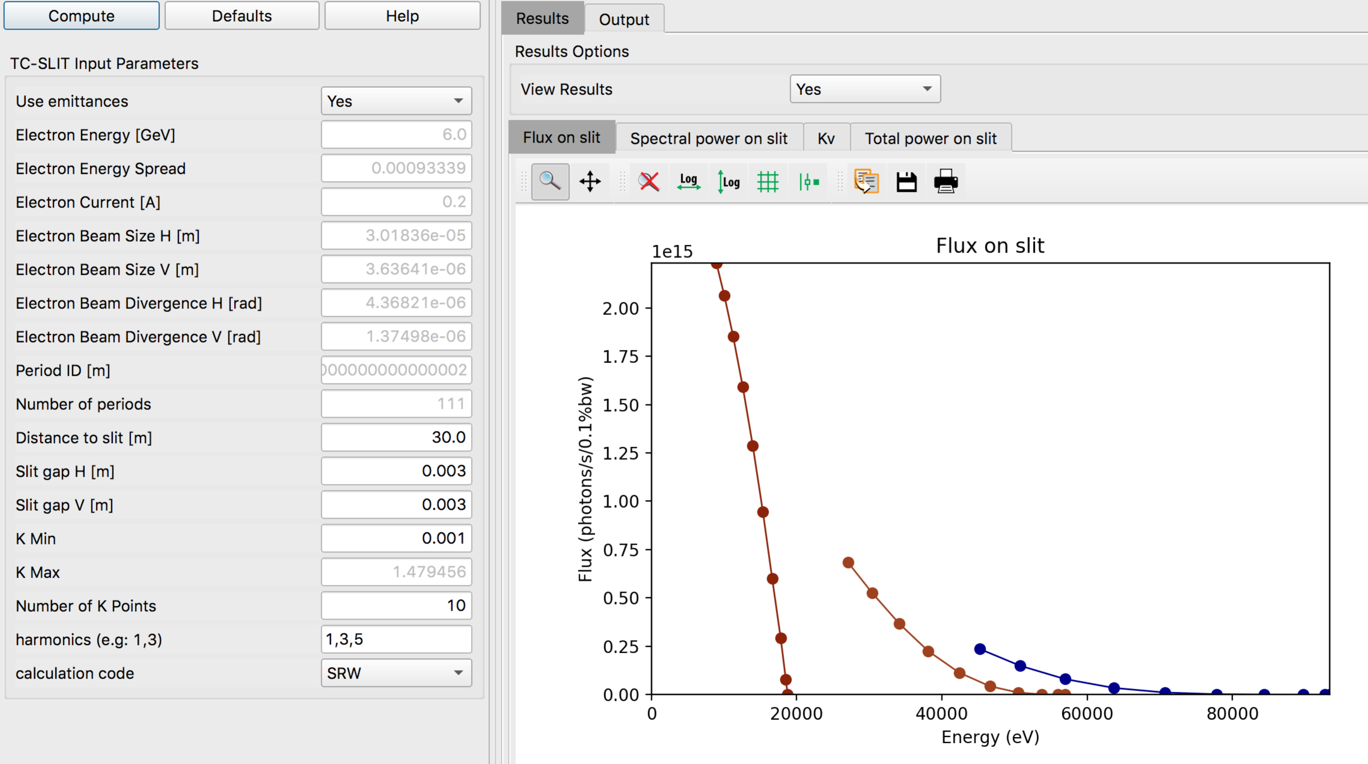

Memorandum:

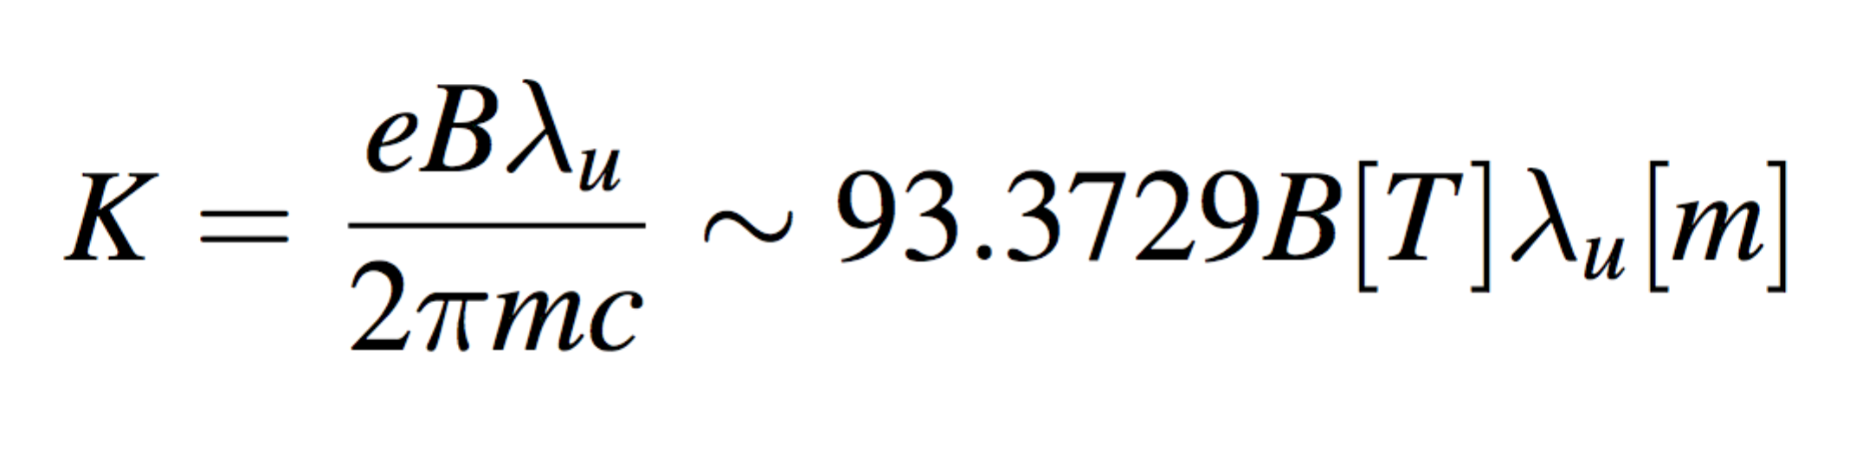

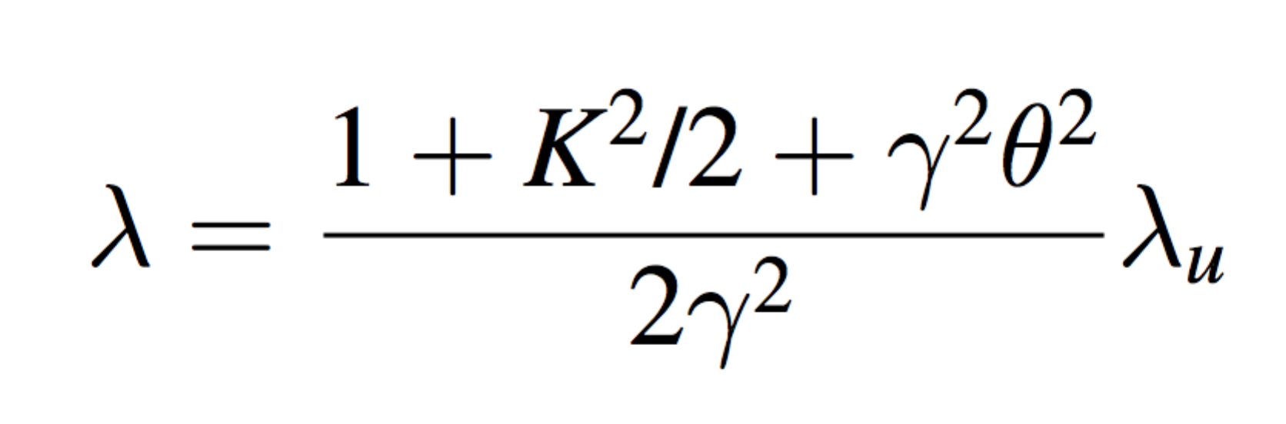

### emission characteristics of synchrotron radiations sources: Undulator sources (power density)

You will learn:

* to calculate the spatial distribution of power emitted by an undulator or wiggler using Undulator Power Density
* Project it on a (plane) optical element
* Approximate the distribution with a Gaussian function.

Calculate the flux and spectral power spectra for an U18 undulator placed at the EBS straight section (e.g., ID06) at 30 m from the source.

Hint: Use a large slit (e.g., 10x10 mm2) to include all the power.

***Answer***

Total power radiated by the undulator with fully opened slits [W]: 7052.41

Power density peak: 299.127441 W/mm2

Total power: 6785.364506 W

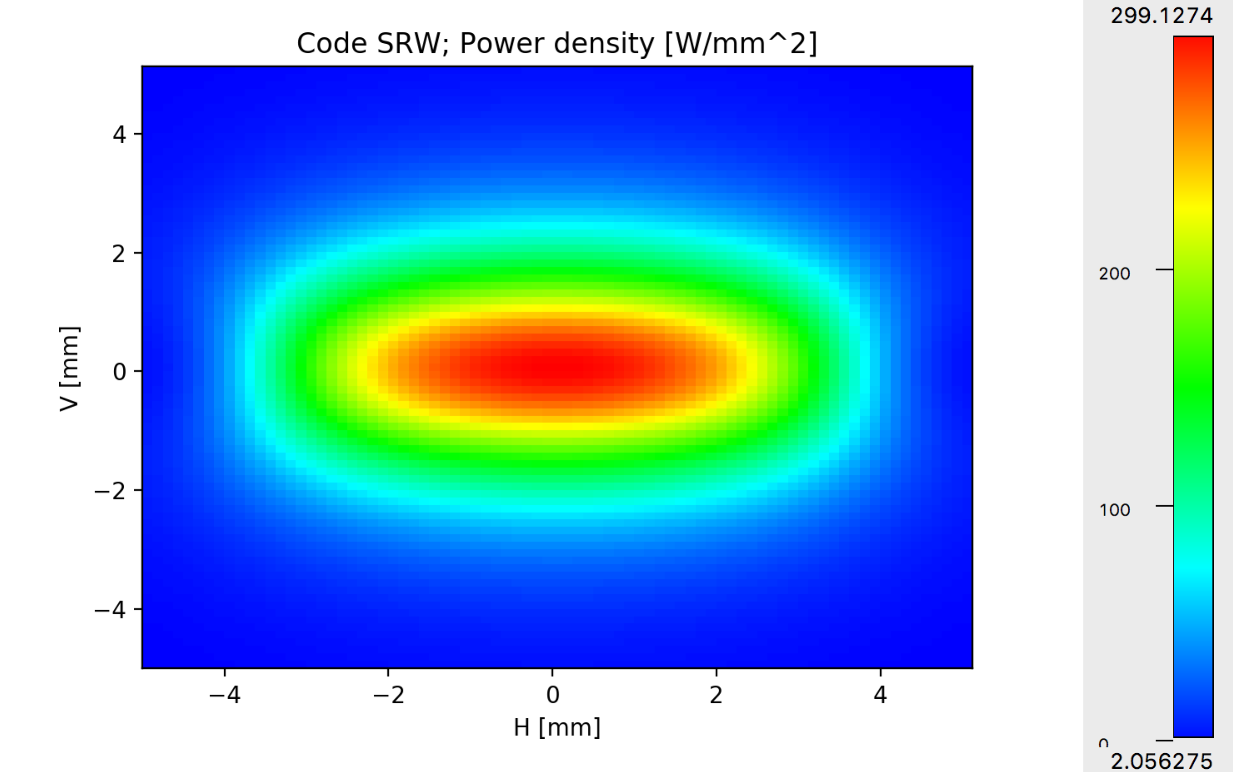

============= Fitting power density to a 2D Gaussian. ==============

Please use these results with care: check if the original data looks like a Gaussian.

Fit 2D Gaussian function:

offset + A * exp( - (1/2)*((x-x0)/sigmax)**2 - (1/2)*((y-y0)/sigmay)**2 )

Height A: 308.061832

center x0: 0.000199

center y0: -0.000001

sigmax: 2.354239

sigmay: 1.411972

offset: 5.423238

Total power in the fitted data [W]: 6785.364484071607

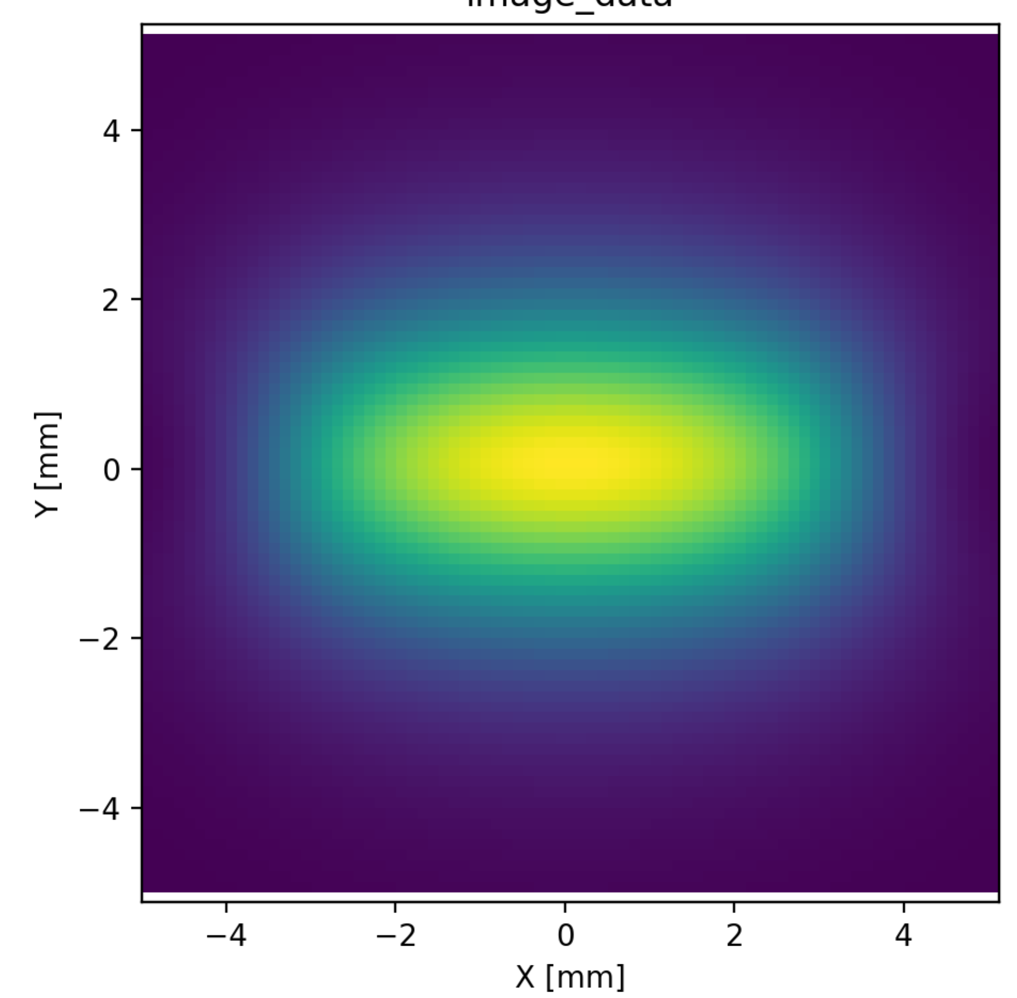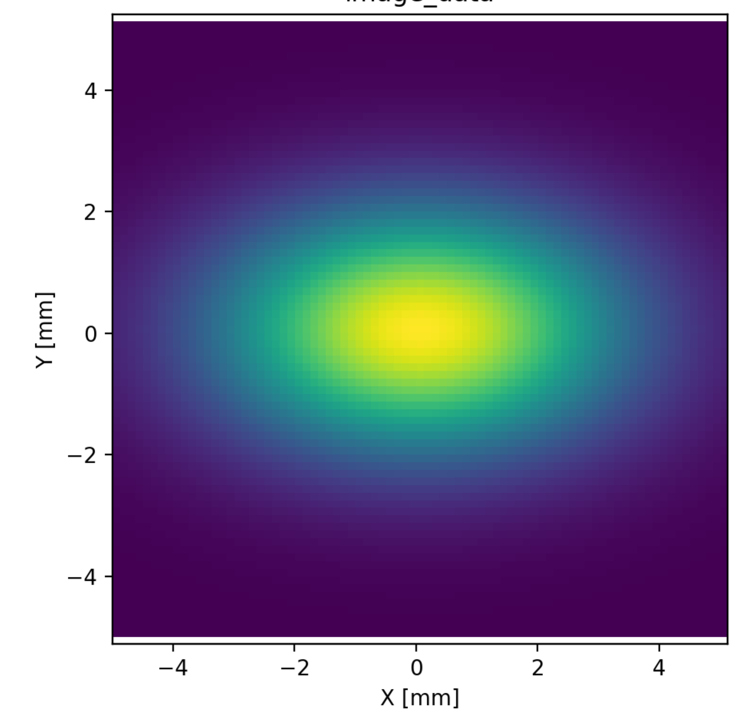Power distribution (left) and Gaussian fit (right)

### emission characteristics of synchrotron radiations sources: Undulator emission vs (x,y,E)

You will learn:

* to calculate the monochromatic angular distribution of the undulator emission using Undulator Radiation

a) Calculate the monochromatoc distribution of flux (at an energy corresponding to the first harmonic, versus emission angle for the U18 EBS undulator. Compare this monochromatoc emission with the white beam power density map of the previous secion.

b) Scan the energy to cover the first harmonic peak and abserve the variation of the spatial flux distribution

***Answer***

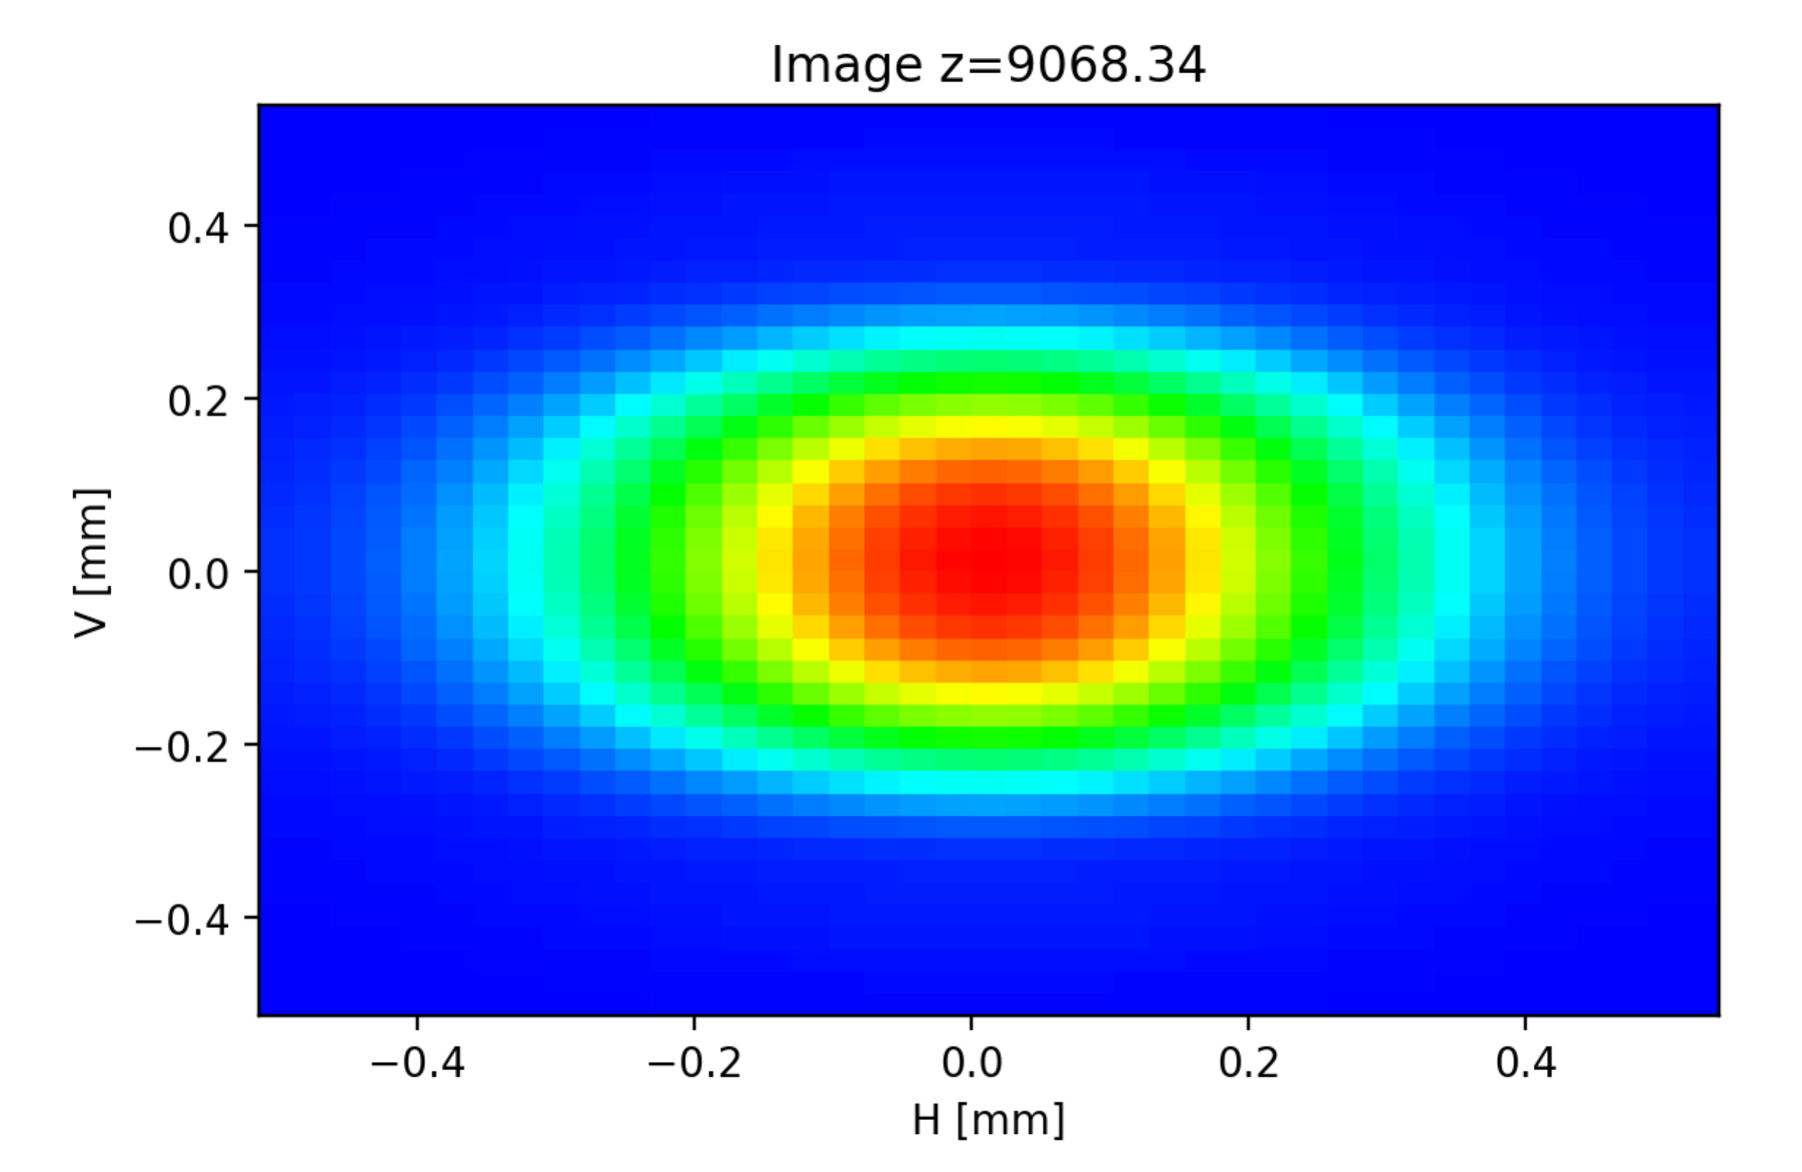

Photon distrubution at resonance

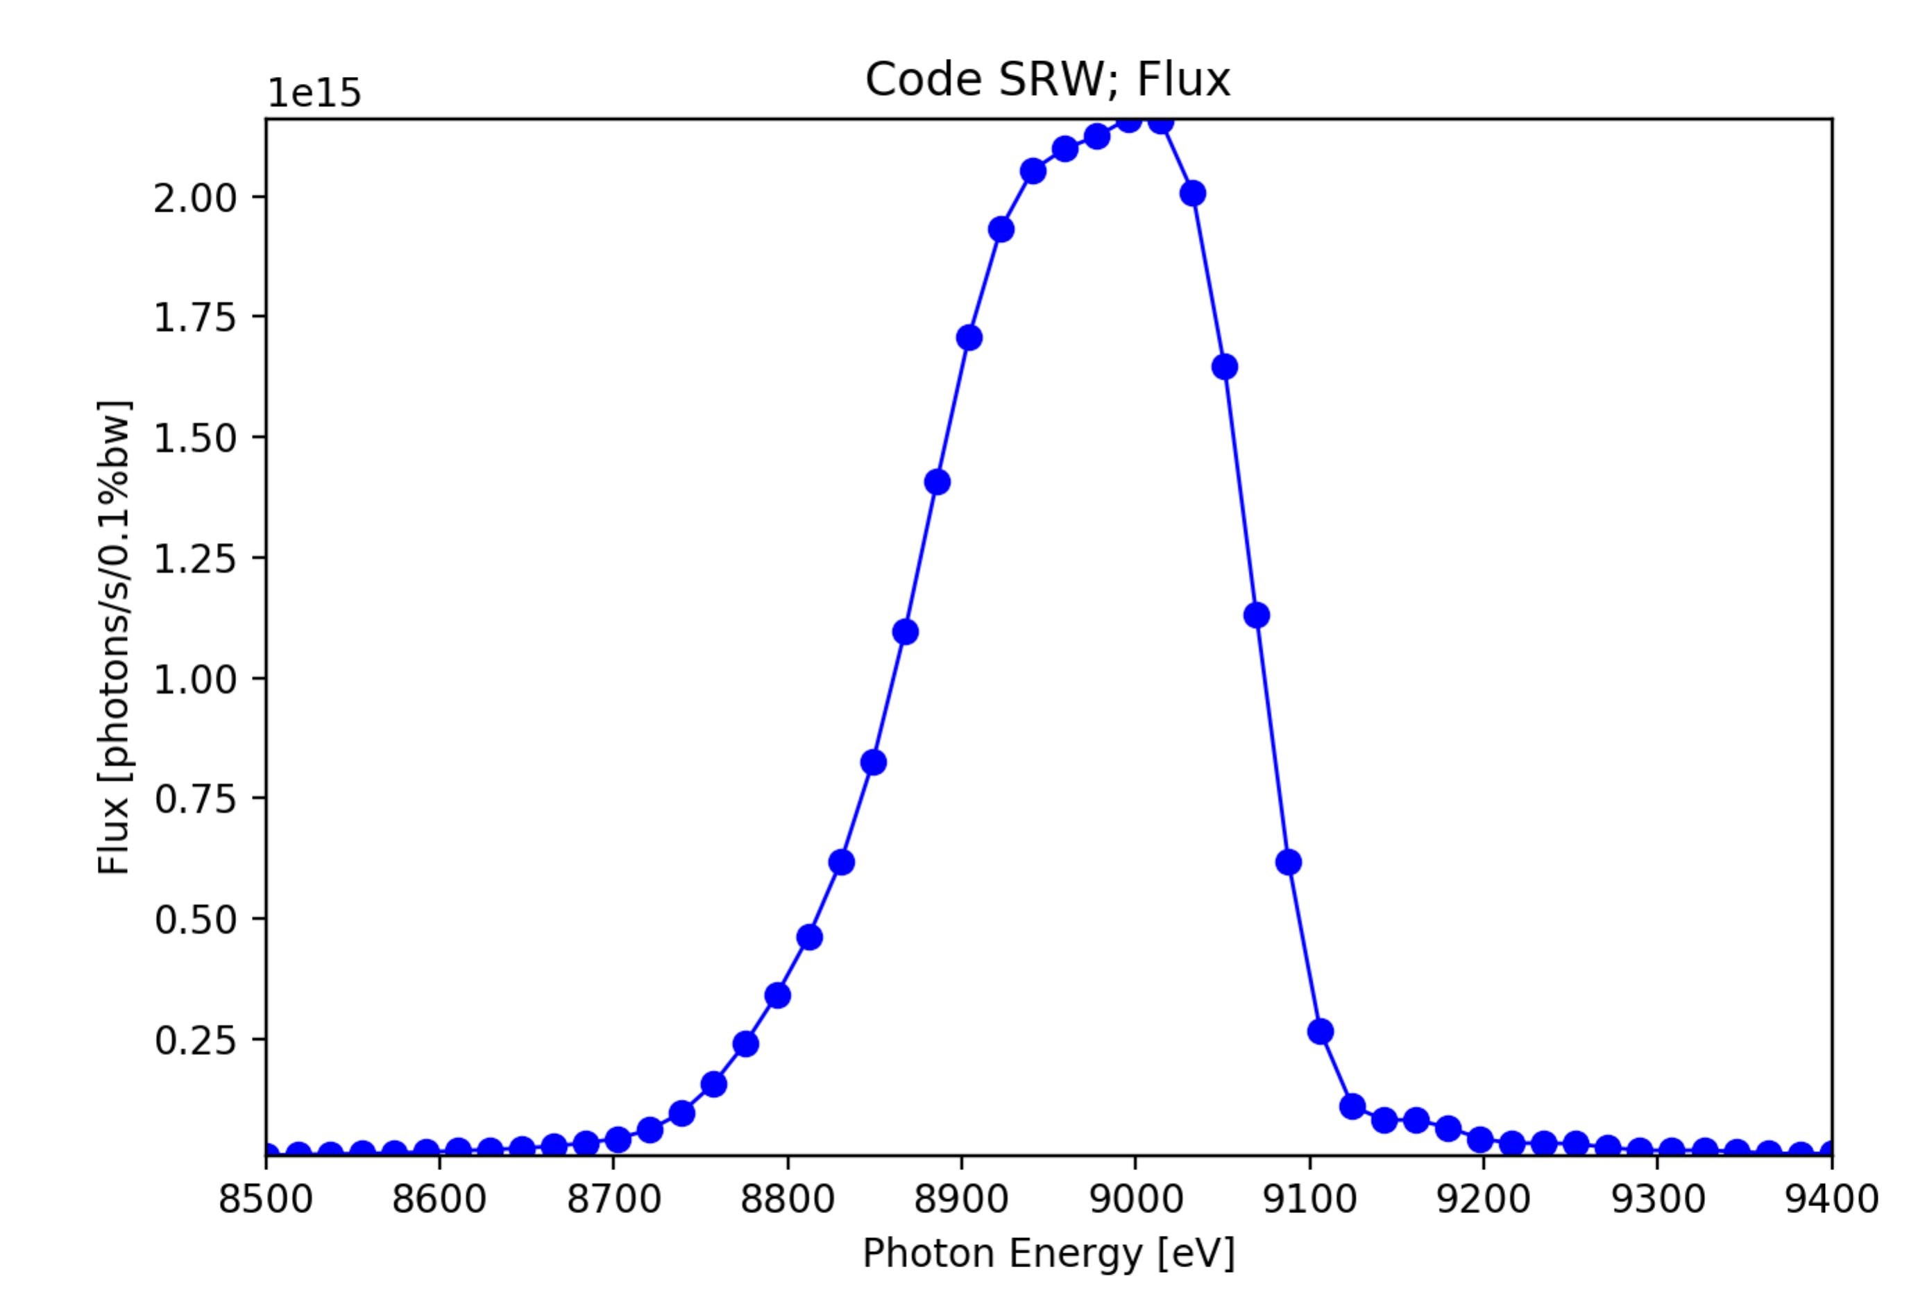

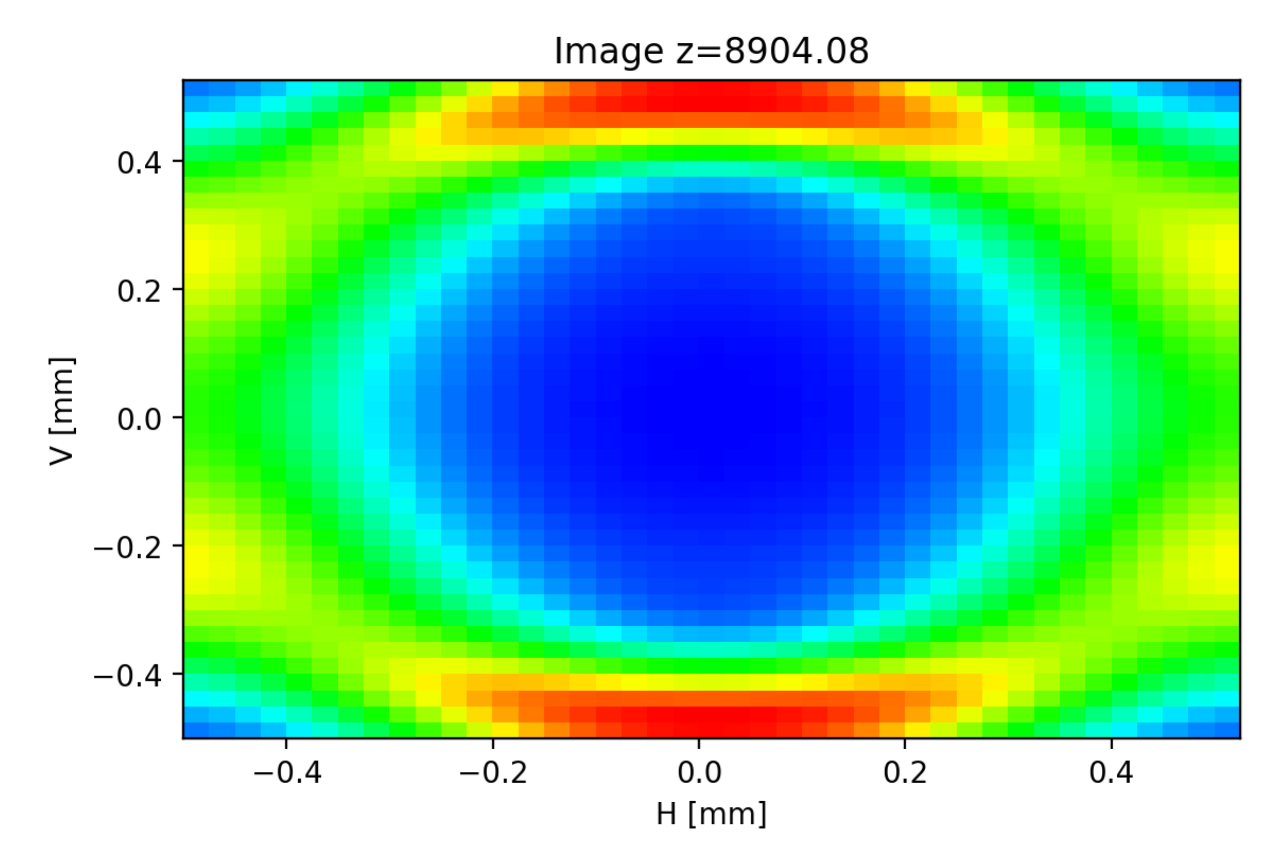 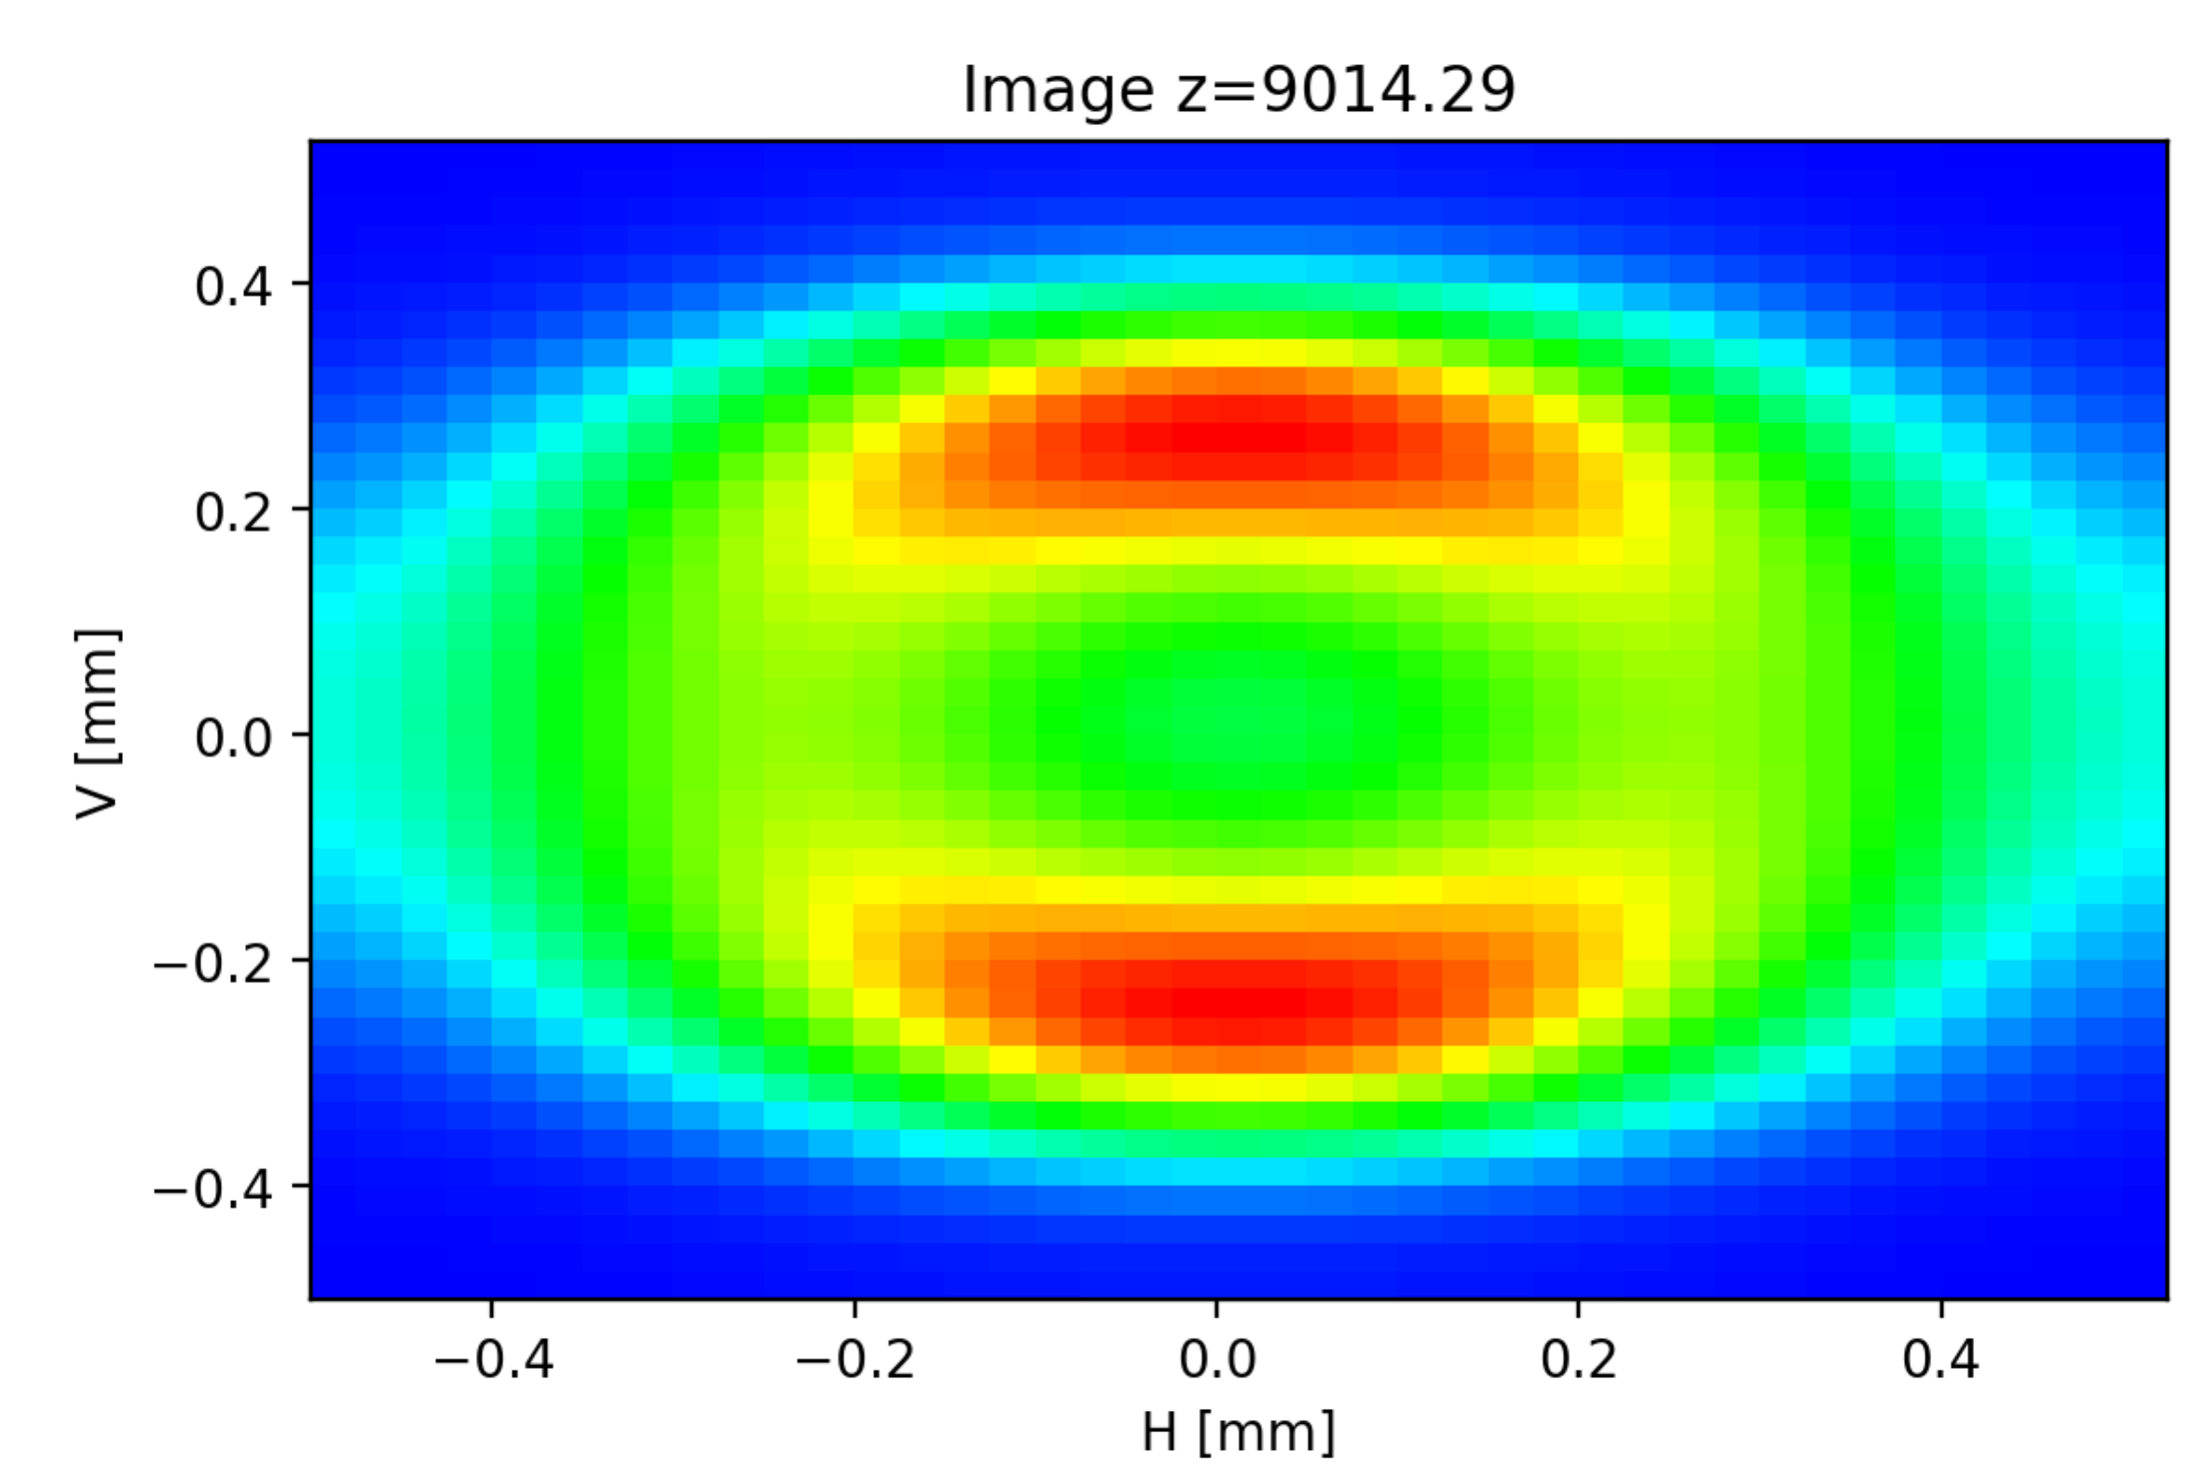

Photon distribution in the ramp up to the peak, at peak and in the down slope (resonance)

Note:

* the position of the flux peak separate from the resonance when slit opens (red shift): Eo is a function of angle
* At the peak a dip or hollow appear in the intensity spatial distribution
* At the resonance (but not at the intensity peak) the emission is smooth. It could be approximated by Gaussians. The approximated divergence and size are:

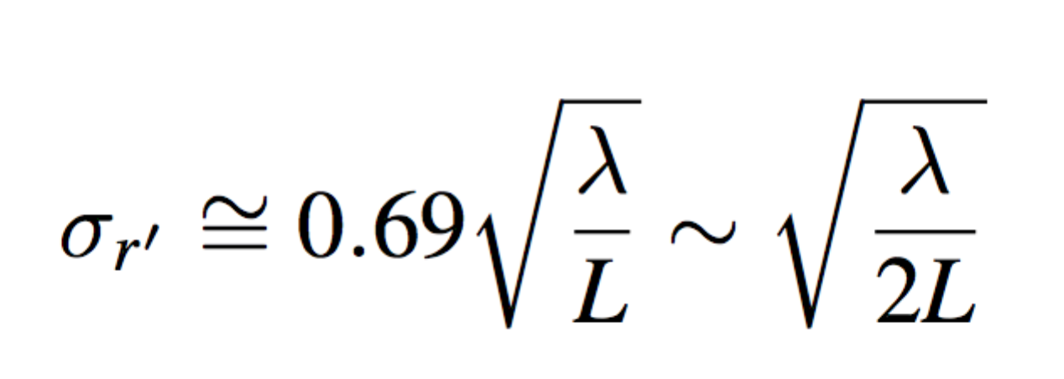 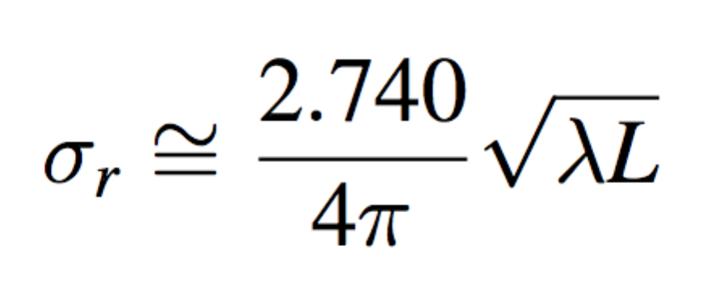 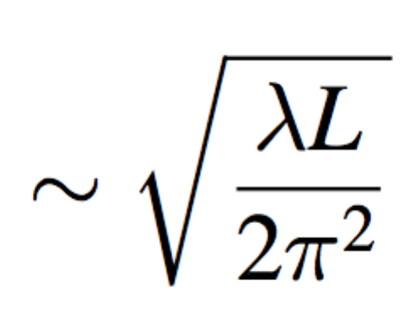

--surface plot of power

--K(gap) (check with id21 application)

--TC see http://www.esrf.fr/machine/support/ids/Public/Brilliance/brilliance.html

--Angular distribution Power map on a screen and on a mirror (after upgrading xsurface1)

### Attenuators and mirrors: effect on source

You will learn:

* to calculate attenuator transmission and mirror reflectivity and to see their effects on the source spectrum.
* evaluate absorbed and transmitted power
* calculate the effect of attenuators and mirrors in power density

Calculate how a 500 m Be window plus a Rh mirror (set at 3 mrad of grazing angle) modify the BM flux calculated in the previous exercise 1. Calculate the absorbed power by these elements. Add other filters (e.g., Al 50 um, Mo 10um).

Hints:

* Use Undulator Source and Power for studying the spectral dependence
* Use Undulator Radiation and Power3D to study the combined spectral and spatial dependence (a very good sampling of the 3 dimensions is needed!)

***Answer***

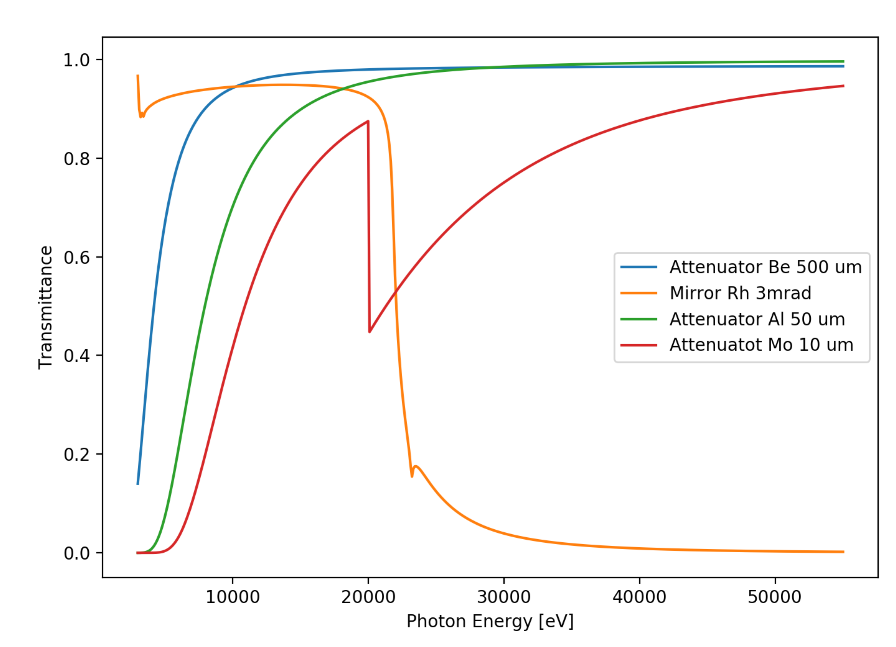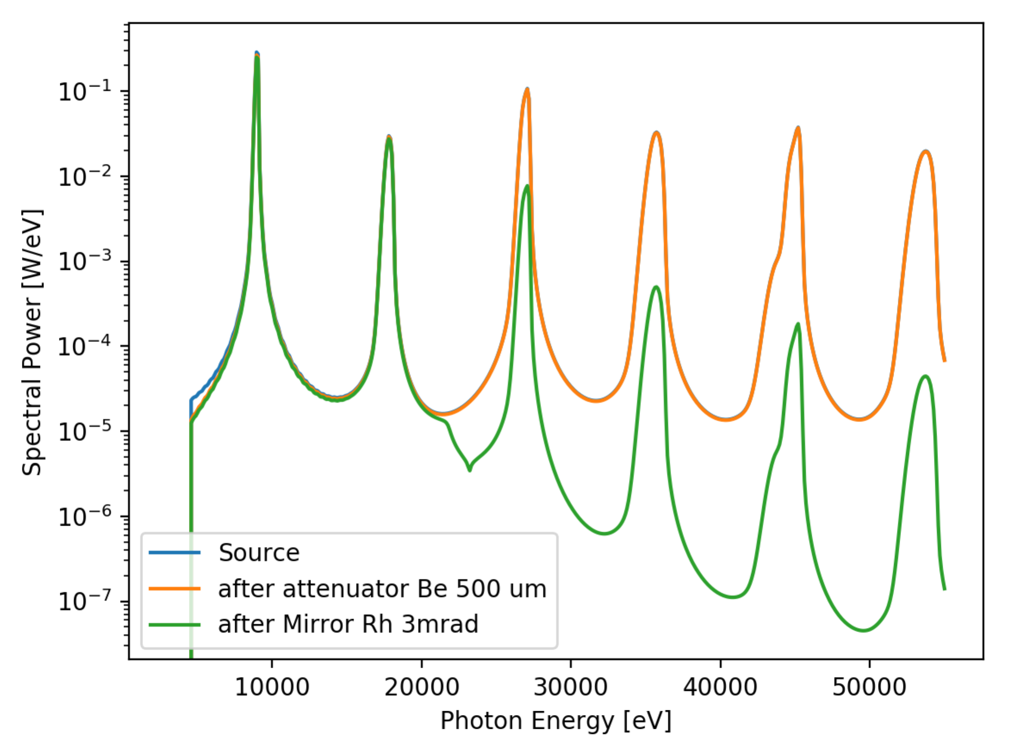

Transmittivity curves (left) and spectral power at the source and after Be filter and Rh mirror.

\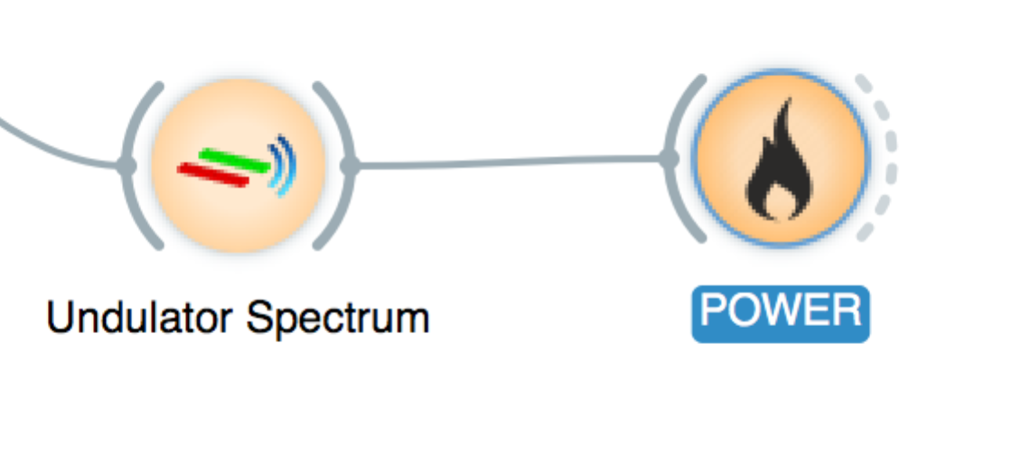 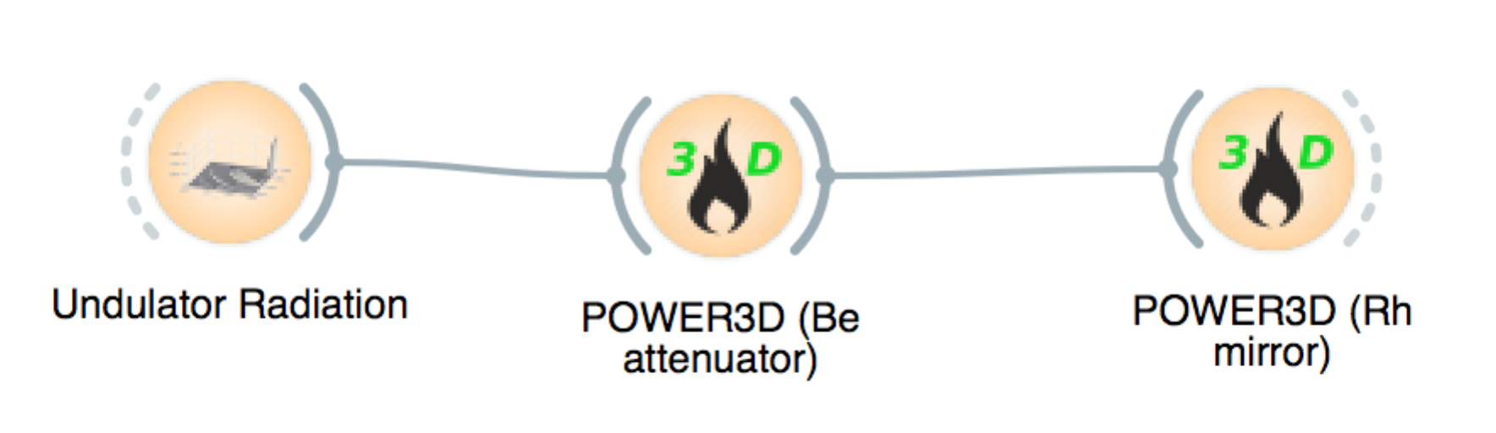

Pay attention to the connections: POWER3D with Undulator Radiation and POWER to Undulator Spectrum

### Crystal monochromators

You will learn:

* calculate diffraction profiles of perfect crystals
* calculate the response of two crystals (+,-) (curve multiplication)
* calculate rocking curves (convolution)
* calculate harmonic suppression

i) Calculate the diffraction profiles, Bragg angle, width, peak and integrated reflectivity of Si 111 at the energies 5 keV, 8 keV, 12 keV, 50 keV, 80 keV and 120 keV.

ii) For the 8 keV case, calculate the diffracted profile of a double Si111 reflection in (+,-) configuration. Calculate the rocking curve resulting of the rotation of the second crystal respect to the first one.

iii) For a Si111 double crystal monochromator at 8 keV, calculate the angular tilt of the second crystal needed to suppress the third harmonic reflection.

Hints:

* For the double reflection (+,-) one should multiply a given diffraction profile by itself.
* The rocking curve is calculated by convoluting the diffraction profile with itself.

For the harmonic suppression one should calculate the main Si111 reflection at 8 keV and the third harmonic (Si333 at 24 keV). Check that both cases give the same Bragg angle. Keep two Xplot windows, one for each profile. Estimate the misalignments one must introduce to suppress the Si333 reflection (should be larger than the diffraction profile width). Create a new set of data for the shifted Si333 reflection by changing the angular (abscissas value with *Xplot|Calculations|Operations with sets*. Save the result to a file. Multiply the original Si333 reflection by the shifted one using the *Xplot|Calculations|Operations with sets* of the Xplot window of the original Si333 Xplot window. Repeat the process of shifting with the main reflection Si111 using the same value of angular misalignment. Calculate the new peak, width and integrated reflectivity, and compare with the double non-misaligned reflection (+,-).

***Answer***

i)

|  |  |  |  |  |
| --- | --- | --- | --- | --- |
| Crystal | E [keV] | W[rad] | Peak | Integ Int |
| Si111 | 5000 | 0.86 | 60.98 | 60.301 |
| Si111 | 8000 | 0.94 | 41.07 | 35.176 |
| Si111 | 12000 | 0.97 | 28.24 | 22.613 |
| Si111 | 50000 | 1.00 | 6.73 | 3.769 |
| Si111 | 80000 | 1.00 | 4.54 | 2.513 |
| Si111 | 120000 | 1.00 | 3.10 | 1.256 |

ii)

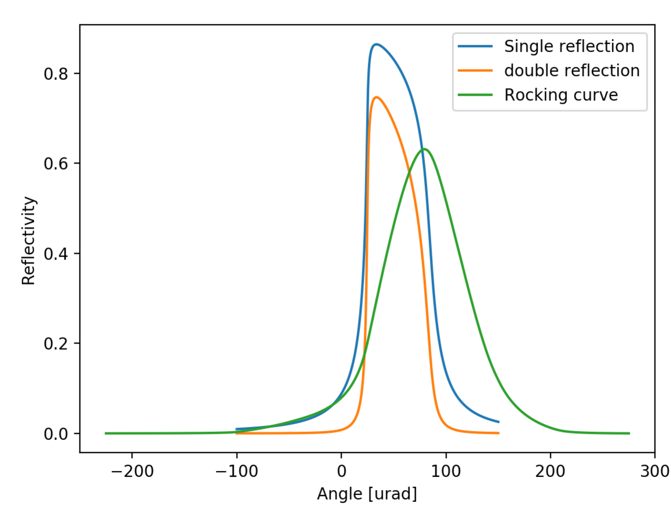

iii)

Si333 single reflection: W=3.1, P=0.99, I=3.45 => Shifting 3.5 rad

Si333.Si333(shifted): W=3.1, P=0.07, I=0.24

Si111.Si111: W=33.8, P=0.88, I=29.2

Si111.Si111(shifted): W=32.3, P=0.88, I=28.4

### Bent crystals

You will learn:

* to calculate diffractions profiles of bent crystals
* understand the limitations of the available models
* to see the transition from dynamical to kinematical theory

i) Calculate the deformation of Si111 symmetric Bragg diffraction profile at 12 keV for different values of the bending radius (5cm, 50cm and 500cm). For each curve calculate the integrated reflectivity and see the transition from the Dynamic theory value (R>>) to the Kinematical theory value (R<<).

ii) Calculate the diffraction profile in Laue for Si111 at 33 keV and asymmetry angle =63.78 deg, and curvature radius 13m.

Hints:

* The multilamellar (ML) model is valid for both Bragg and Laue geometries
* The Penning-Polder model is only for Laue crystals

***Answer***

i)

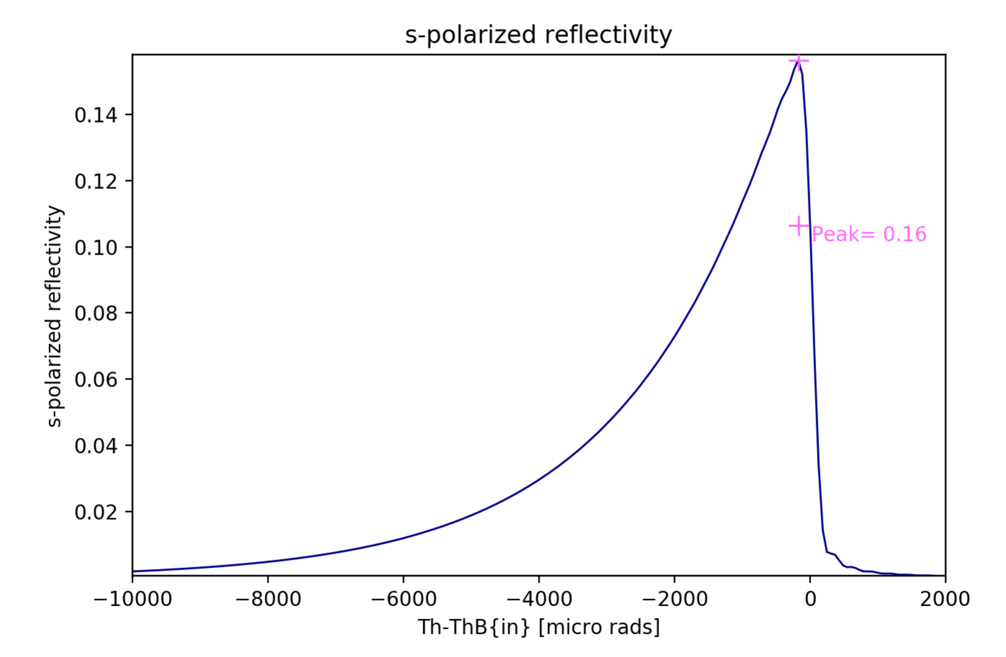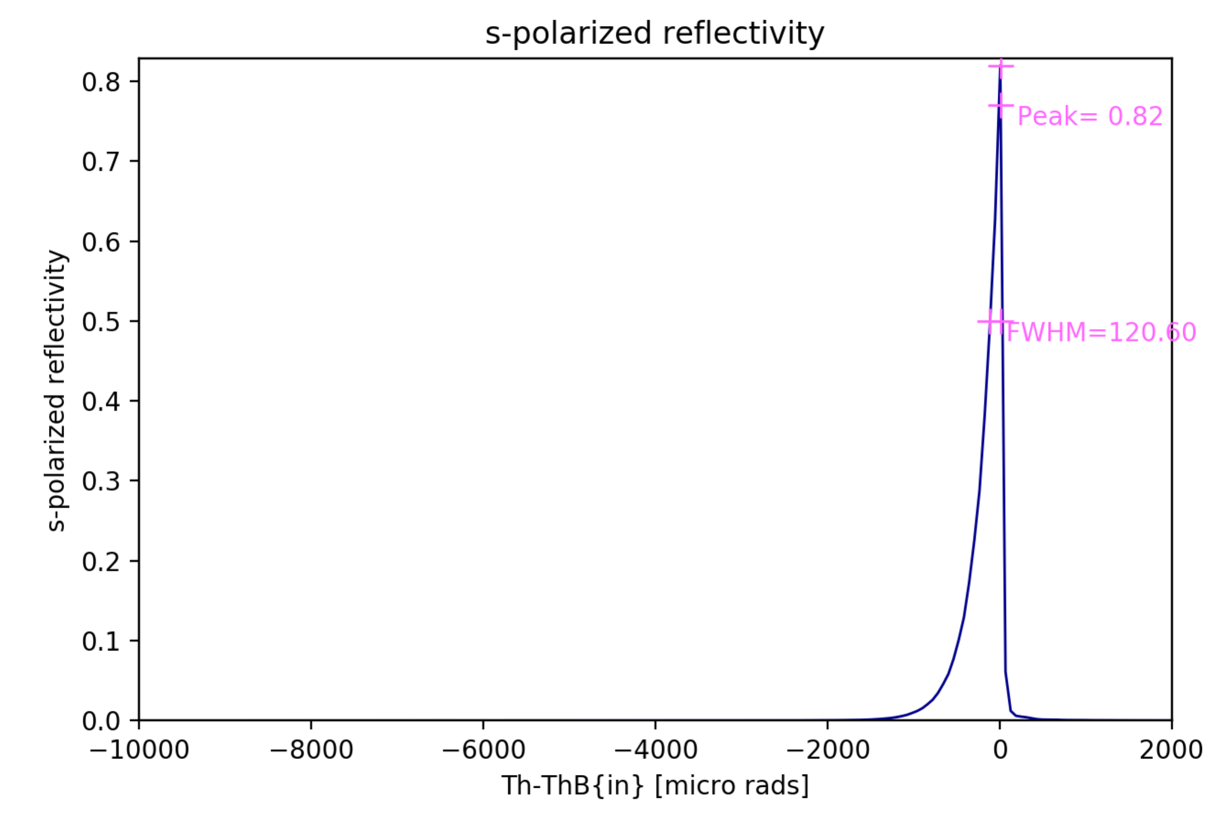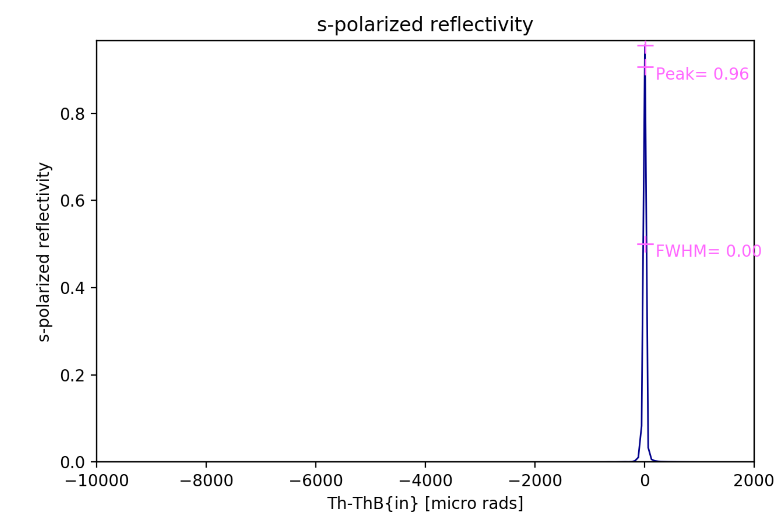

Bragg crystal reflectivity for (from left to right) 5cm, 50cm and 500cm bending radius.

ii)

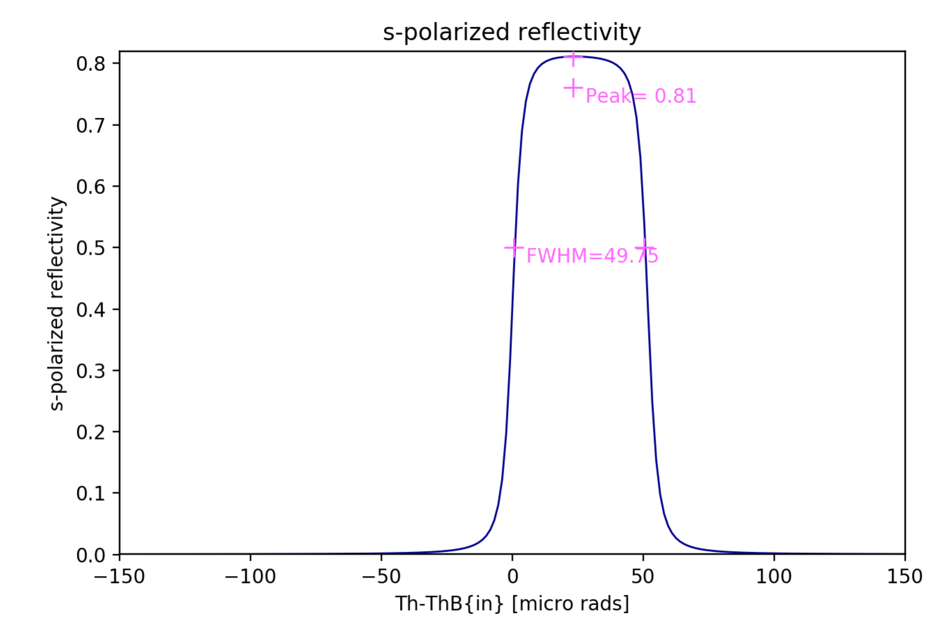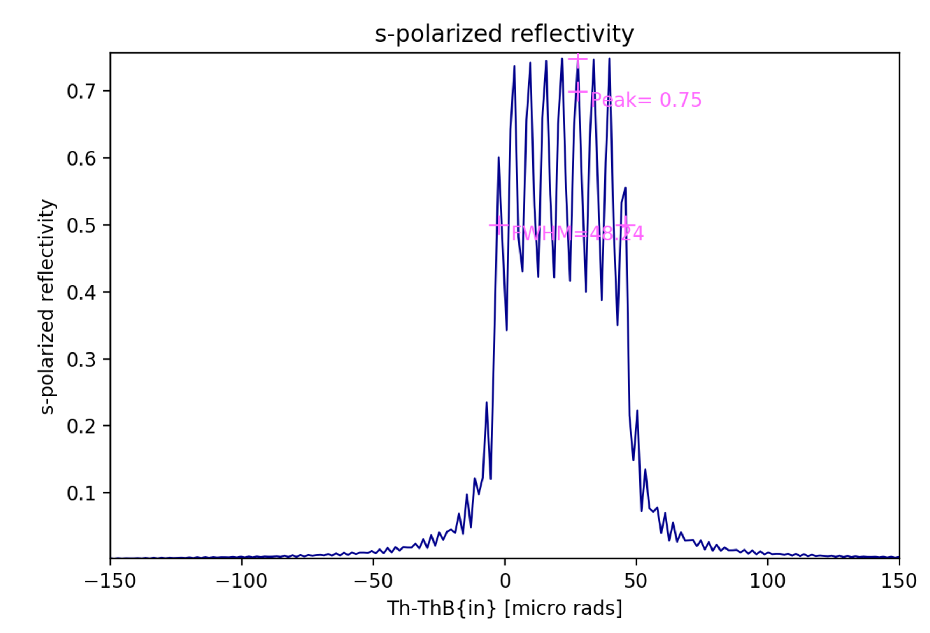

Laue crystal reflectivity using PP model (left) and ML model (right)

Reference: M Sanchez del Rio, N Perez-Bocanegra, X Shi, V Honkimaki, L Zhang (2015) Simulation of X-ray diffraction profiles for bent anisotropic crystals Journal of Applied Crystallography 48: 2. 477-491 <https://doi.org/10.1107/S1600576715002782>

<https://arxiv.org/abs/1502.03059>

### Reflectivity curves of multilayers

You will learn to:

* use Mlayer to calculate reflectivity from simple multilayers
* understand the limitations of Mlayer
* understand the basic features of multilayer reflectivity spectra

i) Using MLAYER calculate the reflectivity as a function of grazing angle, from zero to 6 deg at an energy of 8050 eV

1. [W (25 Å)/Si (25 Å)]×10 on Si
2. [W (25 Å)/Si (25 Å)]×50 on Si
3. [W (10 Å)/Si (40 Å)]×50 on Si
4. [W (5 Å)/Si (45 Å)]×50 on Si

***Answer***

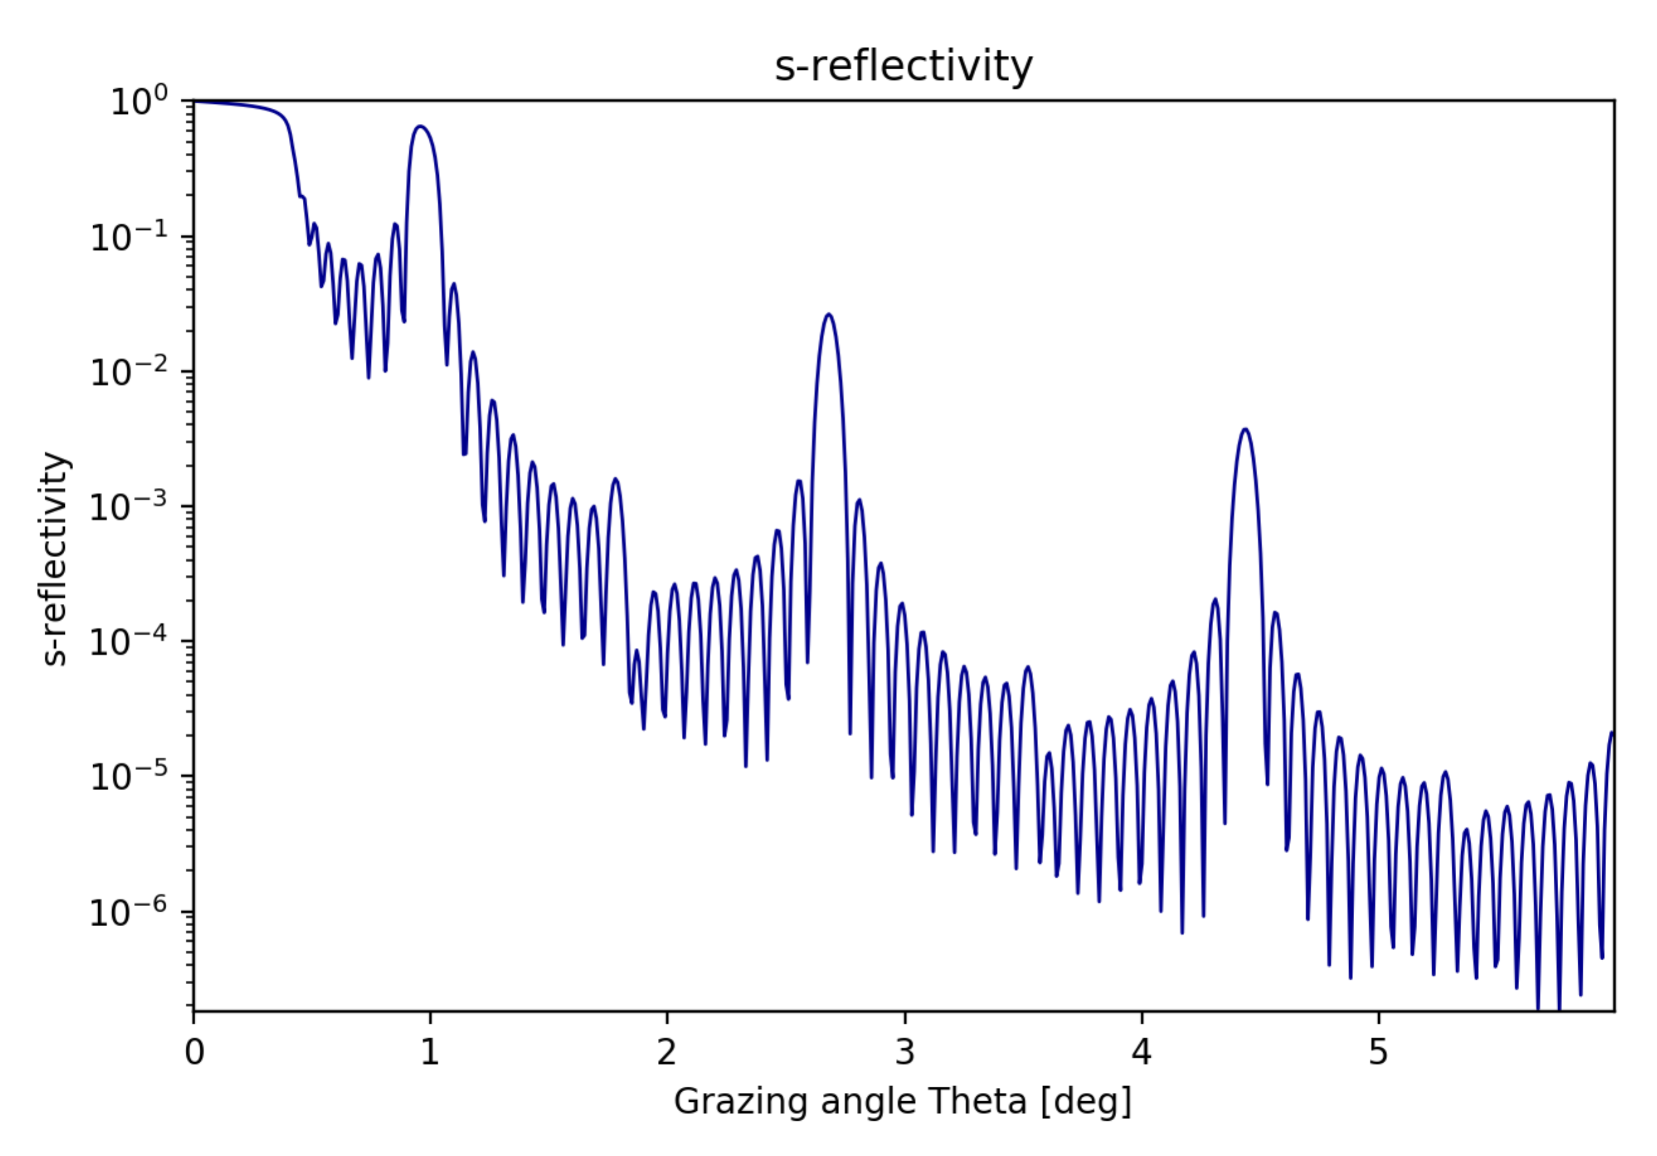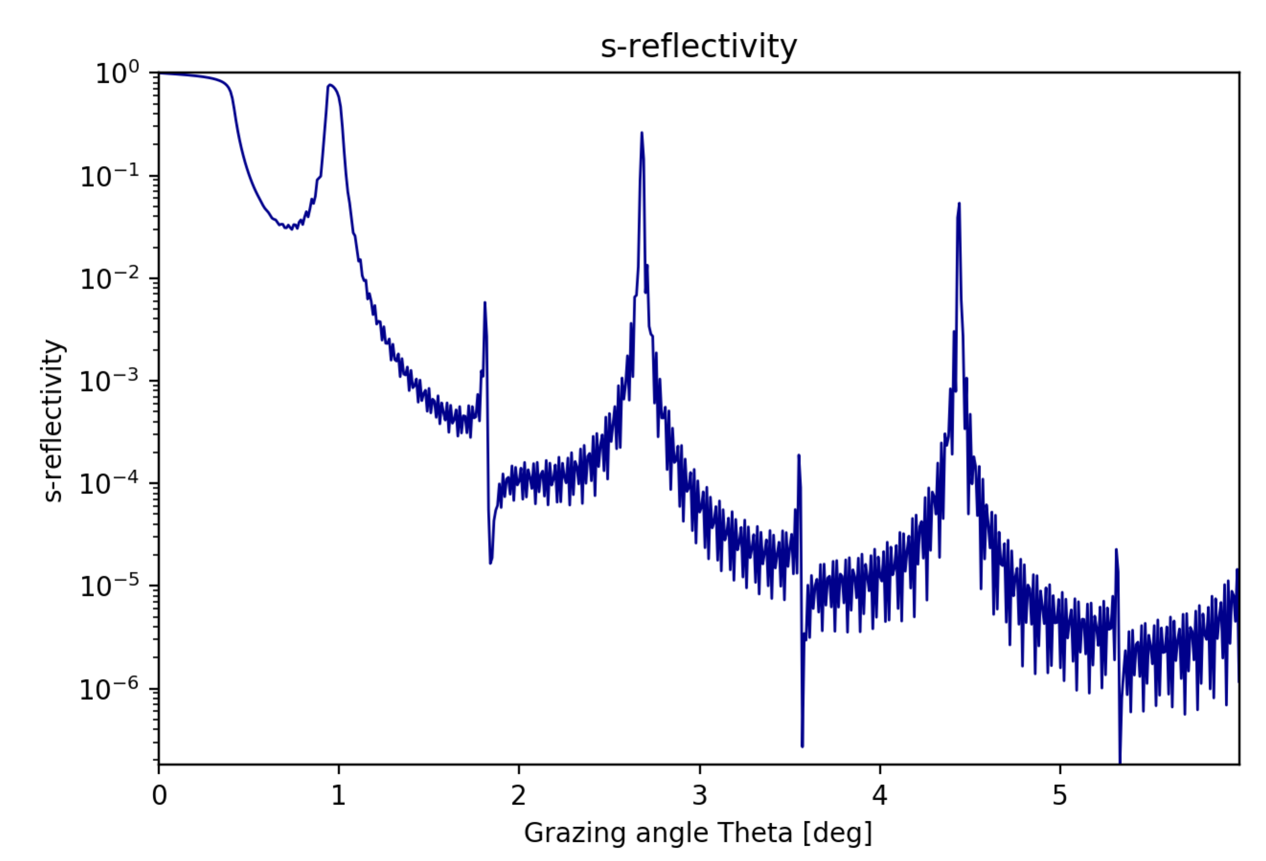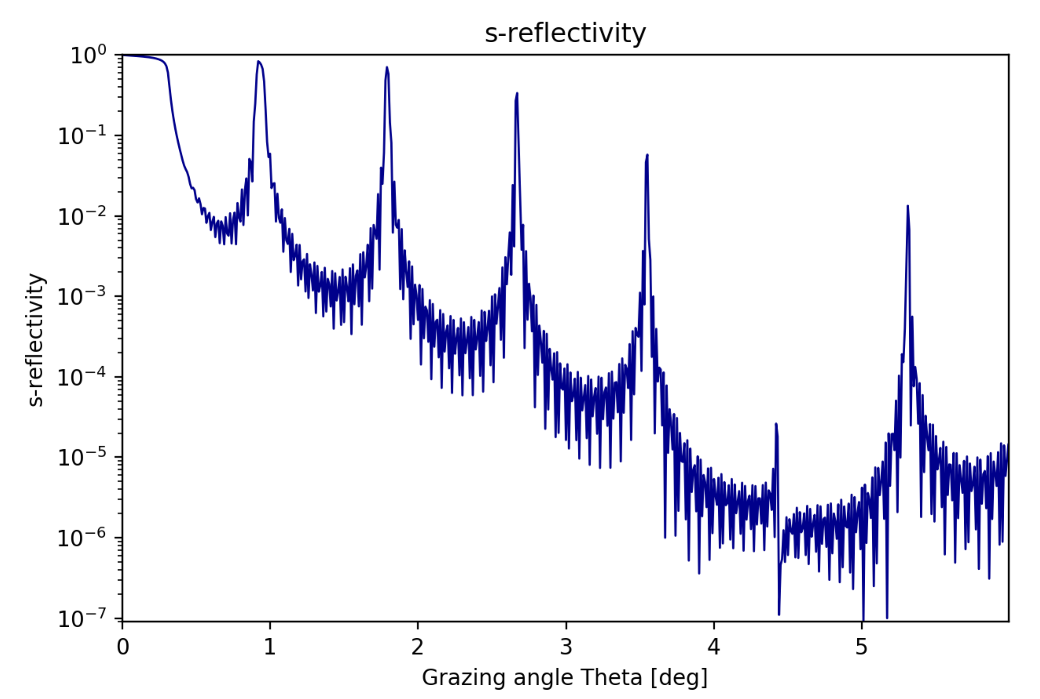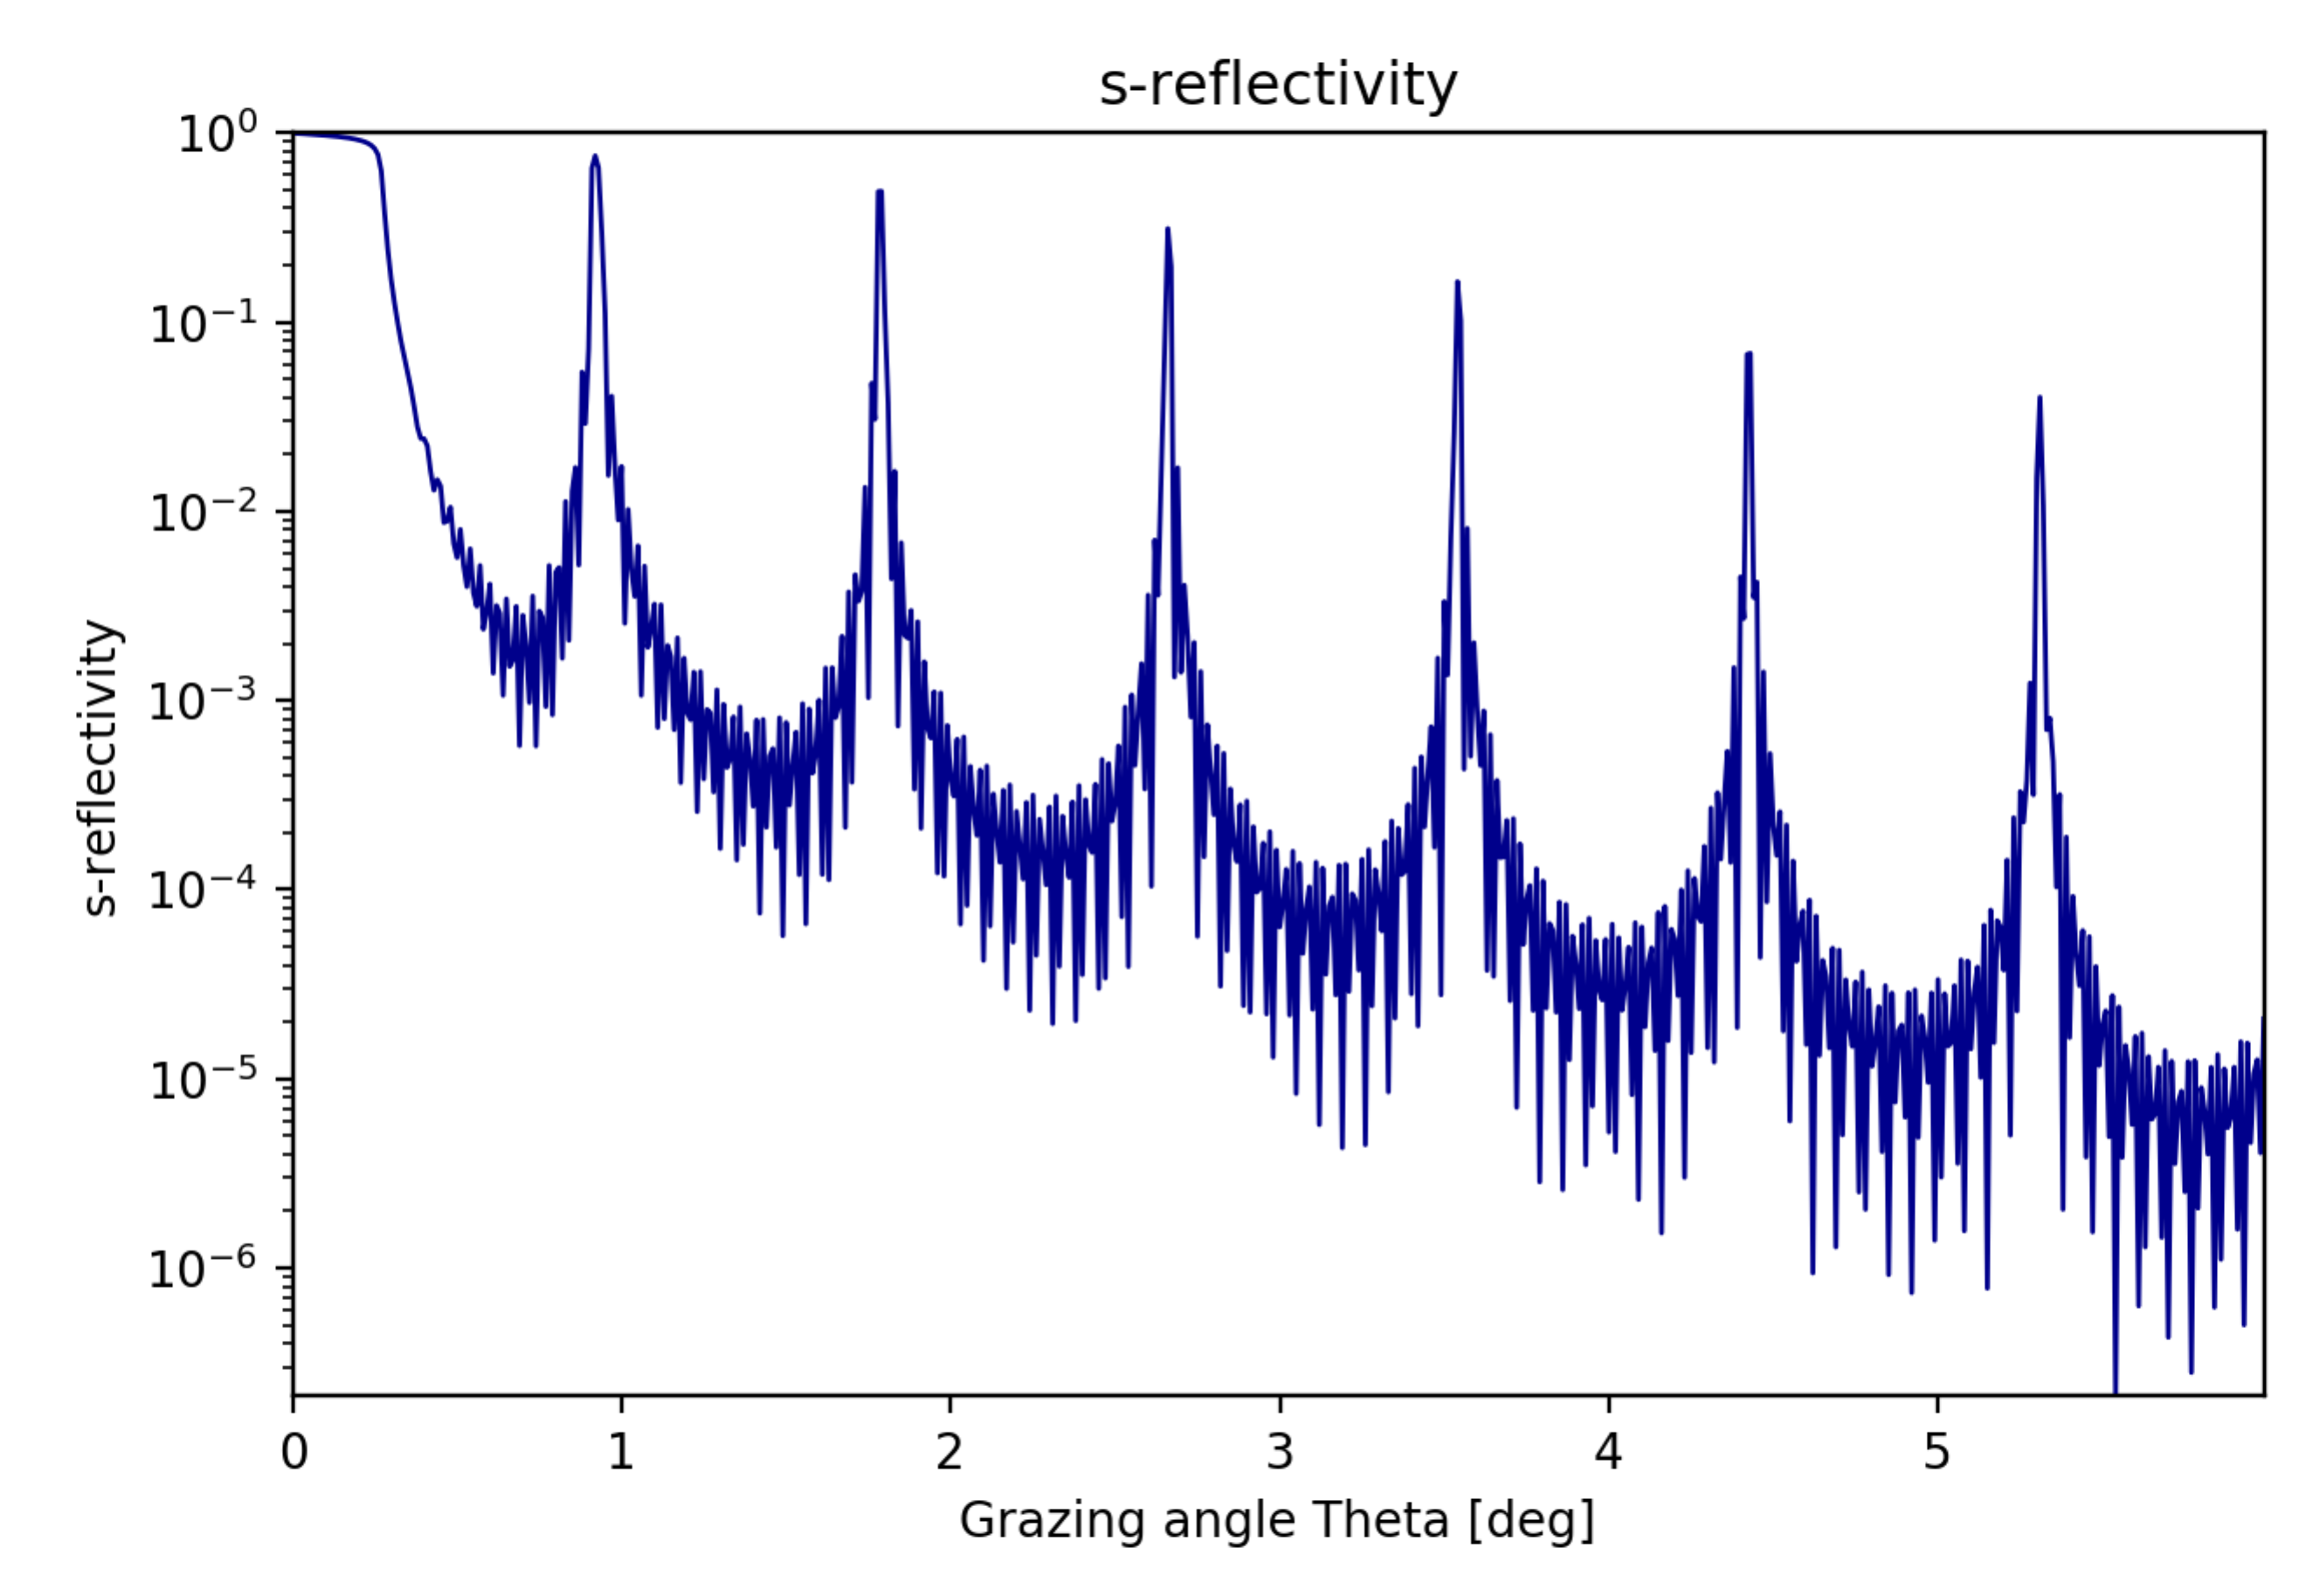

4

3

3

3

1

2

3

The following features can be observed:

1) A plateau corresponding to the total reflection zone.

2) Outside the plateau, the background decreases with q-4. Changes in this background are due to the roughness in the interfaces and experimental background.

3) Satellite maxima. The angular spacing depends on the bilayer periodicity d. Their angular separation is determined by the Bragg law. If the spectrum extends over many peaks, it is possible to observe absences of some peaks, which are related to Γ. Peaks at Γ -1 are absent.

4) Kiessig fringes, which period depends on the total multilayer thickness (i.e., number of bilayers).

5) If a top or capping layer exists (usually an oxide layer) it creates side maxima close to the satellites.

6) The satellite width is proportional to 1/N, N being limited by the absorption of the stack. Although the theoretical width is the same for all satellites, in experimental measurements one usually sees an increase of the satellite width as the satellite order increases.

7) The effect of increasing N is also to increase peak intensity in satellites. This is limited by the roughness and stack absorption.

### Quick tour to other XOPPY applications

Open and run the following applications:

* XRAYLIB
* XCOM
* MARE